**Sales of different TV Task 4 : Write a Mapreduce program to modify Sales of different TV Task 2 ( refer session 5 assignment 2 ) to use a custom partitioner with 4 reducers. Make sure that all records whose company name starts with A-F (upper or lower case) should go to 1st reducer, those starting with G-L to 2nd reducer, those starting with M-R to 3rd reducer and others to 4th reducer**

//driver

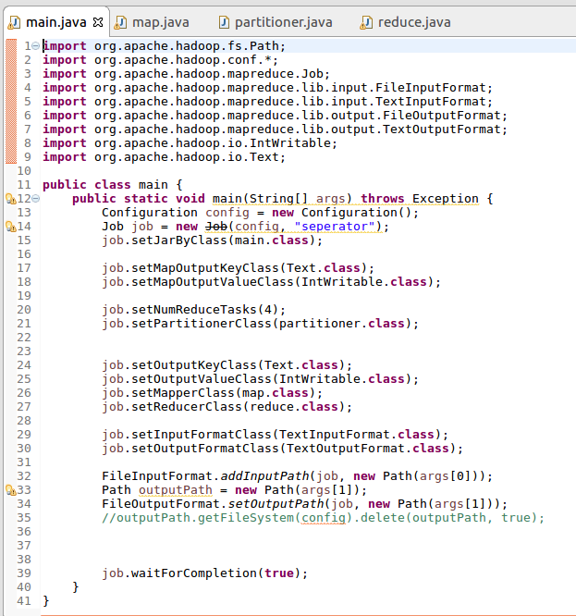

//mapper

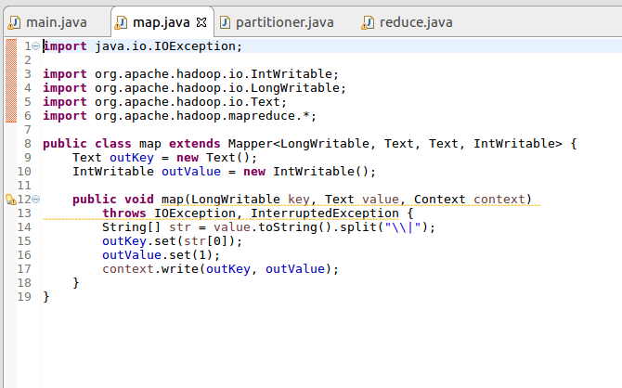

//partitioner

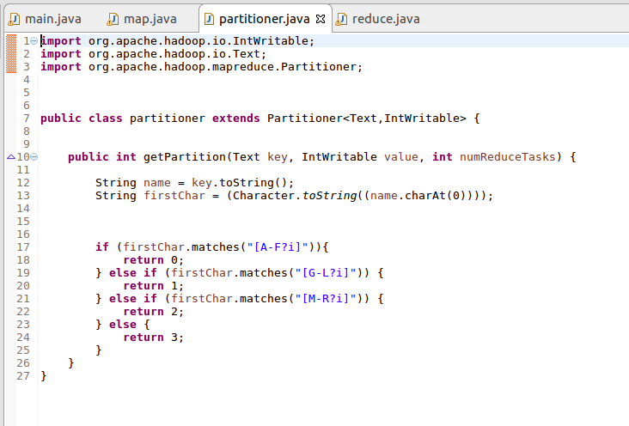

//reducer

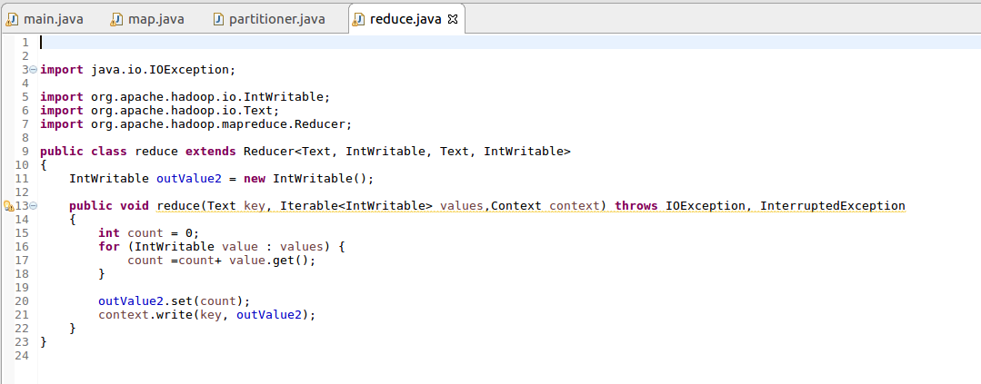

//output

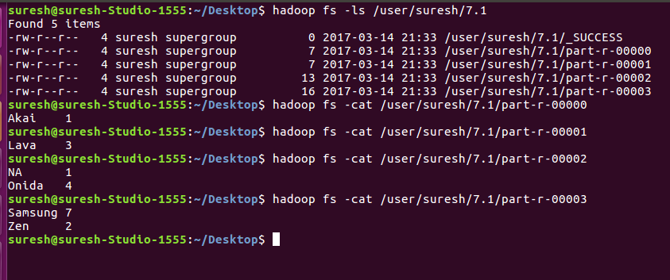

**Sales of different TV Task 5 : Modify Sales of different TV Task 2 (refer session 5, assignment 2) to take advantage of Combiner.**

//driver

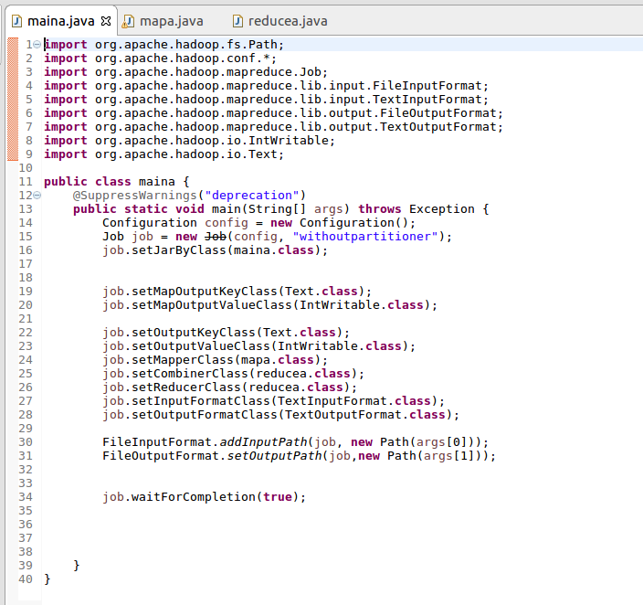

//mapper

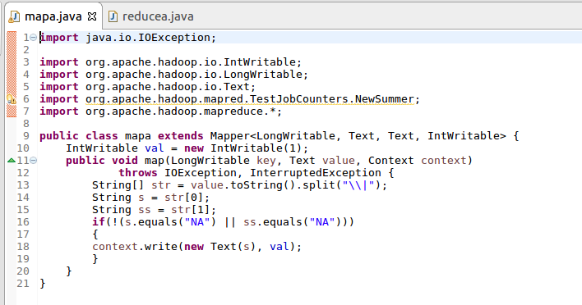

//reducer  
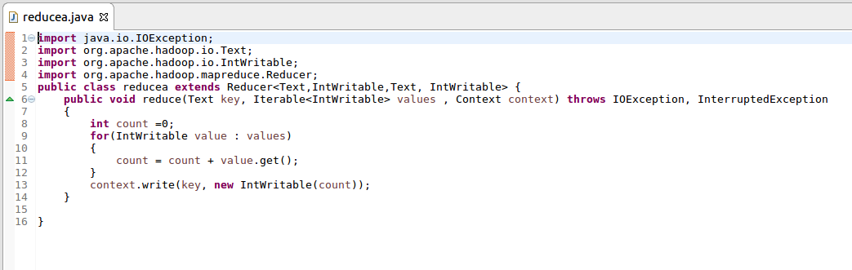

//output

